**Ase1 selectively increases the lifetime of antiparallel microtubule overlaps**

Jochen Krattenmacher1,2, Manuel Lera Ramirez3, Stepan Herynek1, Xiaocheng Liu4, Pavel Neuzil4, Francois Nedelec3, Stefan Diez2,5, Marcus Braun1, Zdenek Lansky1

1 Institute of Biotechnology, Czech Academy of Sciences, BIOCEV, 25250 Vestec, Czechia

2 B CUBE - Center of Molecular Bioengineering and Cluster of Excellence Physics of Life, Technische Universität Dresden, 01307 Dresden, Germany.

3 Sainsbury Laboratory Cambridge, University of Cambridge, UK

4 School of Mechanical Engineering, Department of Microsystem Engineering, Northwestern Polytechnical University, Xi’an, Shaanxi 710072, P. R. China

5 Max Planck Institute of Molecular Cell Biology and Genetics, 01307 Dresden, Germany

**Abstract** | Microtubules are dynamically instable polar biopolymers switching between periods of polymerization and depolymerization. In presence of microtubule-crosslinking proteins, microtubules form overlaps and self-assemble reversibly into complex networks, such as the bipolar mitotic spindle. Differential regulation of microtubule stability in parallel and antiparallel overlaps is essential for the integrity of these networks. Microtubule crosslinkers of the Ase1/MAP65/Prc1 family associate with different affinities with parallel and antiparallel overlaps providing a platform for this differential regulation. How Ase1 regulates microtubule stability in parallel and antiparallel bundles is however unknown. Here, we show that Ase1 selectively promotes antiparallel microtubule overlap longevity, while retaining parallel microtubule overlaps and individual microtubules short-lived and dynamic. In antiparallel overlaps selectively, Ase1 hinders depolymerization and accelerates rescues, thus resulting in increased microtubule lifetimes. We observed Ase1 accumulating at the retreating ends of depolymerizing microtubules. Mathematical modelling suggests that such accumulation is sufficient to decelerate microtubule depolymerization. We propose that differential regulation of microtubule dynamics by Ase1 contributes to mitotic spindle assembly by specifically stabilizing antiparallel overlaps in the midzone, compared to parallelly overlapping or isolated microtubules.

**Introduction** | Spatial regulation of microtubule (MT) organization and dynamics is critical for the assembly of structures such as the mitotic spindle (Nédélec et al. 2003). MTs are dynamic polymers, undergoing stochastic switching between phases of assembly and disassembly, with the switch from the assembly to the disassembly phase termed catastrophe and the opposite process termed rescue (REF Mitchisson & Kirschner). Precise regulation of MTs dynamics is essential for spindle assembly, chromosome segregation, cytokinesis, and polarization of interphase arrays in many cell types. MT-based structures are formed by interconnected MTs and often by lateral association of several MTs into bundles. As MTs are polar filaments, MTs can be bundled in a parallel or antiparallel manner. Within bipolar structures, like mitotic spindles, parallel and antiparallel MT overlaps coexist. While close to the poles MTs tend to be associated parallelly, MTs in the mid-zone form antiparallel overlaps that are essential to the mechanical integrity of the spindle. Importantly, parallel and antiparallel overlaps have different roles, and related to this role, often differ in their stability. For example, antiparallel overlaps in yeast spindles are stable such as to prevent spindle collapse. Thus, investigating the mechanisms by which MT bundles can be stabilized is an important task. A common and crucial component of such a mechanism is a microtubule crosslinker that can distinguish between parallel and antiparallel MTs. Diffusive MT-bundling proteins of the conserved Ase1/MAP65/Prc1 family are a prime example of molecules with this capacity. Geometry of Ase1/MAP65/Prc1 MT binding sites favors antiparallel MT orientation (Kellogg PNAS 2016), which results in increased Ase1/MAP65/Prc1 affinities for antiparallel MT overlaps and preferential antiparallel crosslinking activity (REF Janson et al. Cell, 2007; Bieling, Surrey, Cell 2010) (She et al. 2019). Ase1/MAP65/Prc1 proteins are found *in vivo* preferentially at the spindle midzone, and are involved in spindle integrity and regulation of spindle elongation (Löiodice 2005, Yamashita 2005) (She et al. 2019). Ase1 deletion mutants, although viable, exhibit interphase MTs with reduced bundling and mitotic spindles that often fall apart during the spindle elongation in anaphase (REF).  The preferred binding of Ase1/MAP65/PRC1 family proteins to antiparallel MTs leads to the recruitment of other proteins at the midzone that can locally alter MT dynamics, such as CLASP (REF) or kinesin-4 (Bieling Cell 2010). By recruiting these additional factors, Ase1 family proteins can differentially regulate the dynamics of bundled MTs, specifically affecting the dynamics of antiparallel bundles, without changing the polymerization dynamics of isolated MTs (Bieling Cell 2010; Mani, Subramanian Nat Chem Biol 2021). Additionally, Ase1 family members themselves are also known to have direct effects on MT dynamics. In vitro experiments have shown that MAP65-1, upon crosslinking microtubules, promotes rescues (Stoppin-Mellet et al. 2013). Based on the modeling of their observed overlap dynamics, Stoppin-Mellet *et al*. predicted MAP65-1 to have more effect on antiparallel MTs compared to parallel ones. This is in line with the known preferential binding of MAP65-1, PRC1 and Ase1 to antiparallel overlaps (Gaillard et al. 2008) (Subramanian et al. 2010) (Janson et al. 2007). However, direct characterization of Ase1/MAP65/PRC1 regulating microtubule dynamics, in parallel and antiparallel microtubule bundles is still lacking.

We show that Ase1 is sufficient to extend the life of antiparallel overlaps, in conditions where single microtubules remained highly dynamic and short lived. This differential regulation is due to a promotion of microtubule rescue and a decrease of microtubule disassembly speed, specifically in antiparallel overlaps. As we observed that Ase1 density at microtubule tips during microtubule disassembly correlates with a decrease of tubulin disassembly, we propose that Ase1 reduces the dissociation rate of terminal tubulin subunits from microtubules. Under this assumption, Ase1 propensity to oppose depolymerization is amplified for antiparallel microtubules, leading to their specific stabilization, compared to parallel overlaps and isolated microtubules.

**Ase1 selectively promotes persisting antiparallel microtubule overlaps** (fig. 1)

To study the interactions between diffusible MT crosslinkers and depolymerizing MT tips, we employed total internal reflection (TIRF) time-lapse imaging of immobilized, GMPCPP-stabilized MT seeds in the presence of free tubulin and 42 nM Ase1 (Methods). Under these conditions, we observed dynamic, Ase1-decorated MT extensions growing from the MT seeds. When two microtubule plus ends, emanating from different seeds and growing towards each other encountered, these microtubules either bundled or crossed, in a manner dependent on the angle of incidence. Typically, at high angles the MTs crossed and only interacted at the crossing point, while at small angles either parallel or antiparallel association could be formed. As has been reported before (Janson et al. 2007), we observed antiparallel bundles to form readily, even at large angles of incidence (up to 40°), while parallel bundles only formed at angles below 20° (Figure S1A). Quantitative analysis revealed increased lifetimes of antiparallel overlaps compared with parallel ones (Figure 1A-E). Notably, at 42 nM Ase1 in solution, the Ase1 density on antiparallel overlaps was much higher than on parallel, consistent with the previously reported differential affinities (Janson et al. 2007). Repeating these experiments with 420 nM Ase1, we observed the density of Ase1 to be similar on antiparallel and parallel bundles, roughly twice the density found on isolated MTs (Figure 1F). This possibly simply indicated that, at this high concentration, all binding sites on the microtubules were occupied by Ase1. Despite similar decoration levels by Ase1, antiparallel overlaps were nevertheless significantly more stable than parallel ones. Given the low growth speed of minus ends, we very rarely observed antiparallel overlaps formed by two minus ends encountering each other, and we thus could not meaningfully quantify the associated lifetime, but this configuration is less relevant to the *in vivo* conditions than overlaps formed by growing plus ends. Importantly, Ase1 could on its own selectively extend the lifetime of antiparallel microtubules.

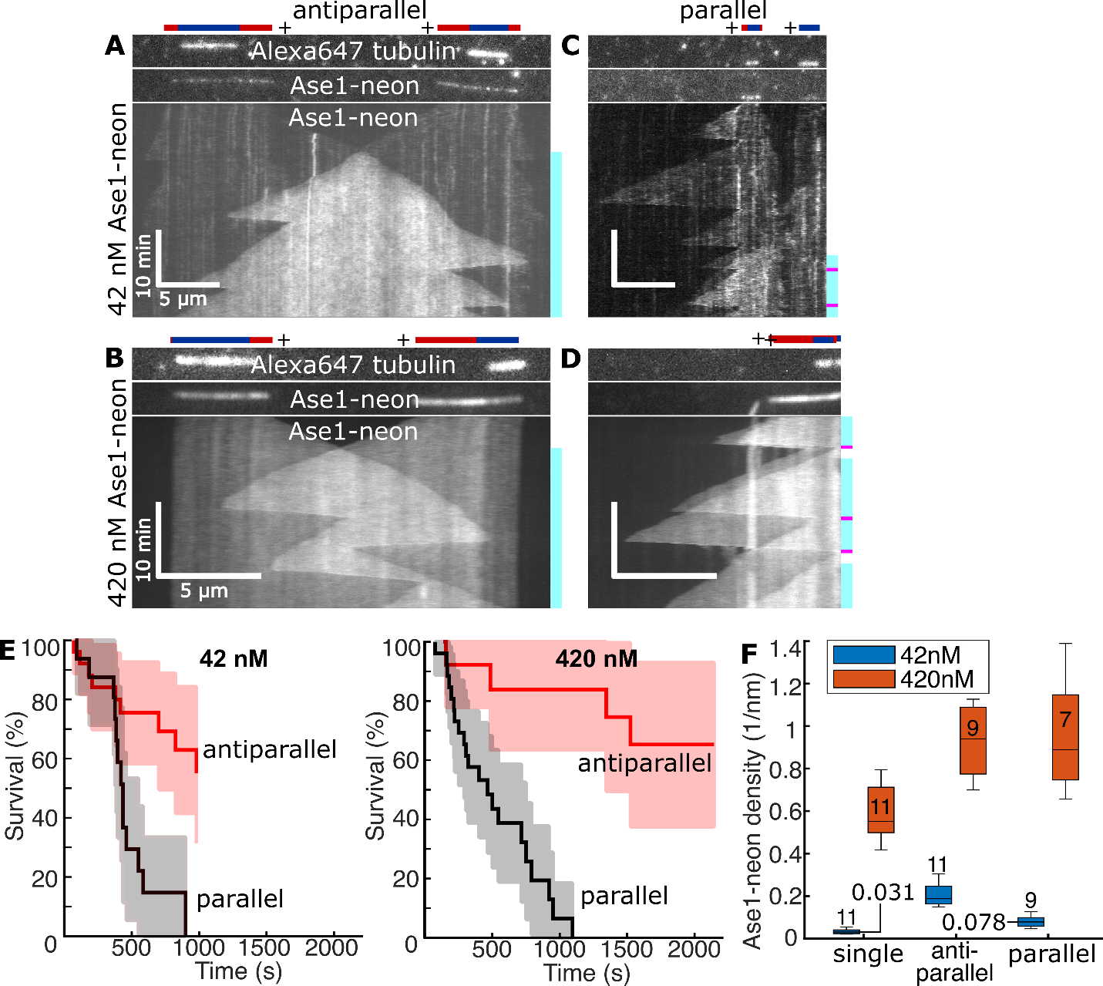

**Figure 1. Ase1 selectively promotes persisting antiparallel microtubule overlaps.**

**A/B**Kymographs of two microtubules growing into each other in the presence of 42nM (respectively 420 nM) Ase1-neon, subsequently forming a persisting region of antiparallel microtubule overlap. In sketches, dynamic extensions with GDP lattices are colored red, and stabilized GMPCPP seeds are colored blue. The teal bars next to kymographs indicate the presence of regions of overlap (we only counted regions where the two partaking microtubule regions are constituted by GDP-tubulin, i.e., a seed stabilized by GMPCPP did not count). The pink bars indicate a termination of the overlap region, as evaluated for E. **C/D**Kymographs of two microtubules growing in a parallel configuration in the presence of 42nM (respectively 420 nM) Ase1-neon, sometimes forming a region of overlap. **E**Quantification of the relative persistence of antiparallel configurations compared to parallel configurations (Methods). Semitransparent lines indicate 95% lower and upper confidence bounds. **F**Quantification of the density of Ase1-neon on regions of interest (Methods). The numbers inside the boxes denote the number of measured regions (one region per MT). Panels show data for MT plus ends (minus ends were not analyzed).

**Ase1 differentially regulates microtubule dynamics** (fig. 2)

To investigate further how  antiparallel overlaps are stabilized by Ase1, we recorded the microtubule growth speed and Ase1 density. We found that, at 42 nM Ase1 concentration, polymerization velocities and catastrophe frequencies were similar for all microtubules, either isolated or involved in overlaps (Figure 2,S2). By contrast, antiparallel overlaps displayed a marked decrease in microtubule polymerization velocity and a pronounced increase in rescue frequency compared to isolated MTs and parallel overlaps (Fig. 2c). This observation can be expected given the increased Ase1 density on antiparallel MTs at 42 nM Ase1 (Fig. 2e,f). Analyzing MT dynamics at elevated 420 nM Ase1 concentration revealed similar effects on MT dynamics. Isolated microtubules and parallel ones displayed similar dynamics, which can be expected given that they have similar quantities of Ase1 (Figure 1F). Antiparallel MTs, however, exhibited again increased rescue frequency compared to single and parallel ones (Fig. 2a-d) despite the fact that at 420 nM Ase1 concentration, the Ase1 decoration level of antiparallel and parallel overlaps was comparable (Fig. 2e,f and Fig. 1f). These results suggest that antiparallel Ase1 crosslinking is sufficient to stabilize microtubules. Higher Ase1 concentration reduced polymerization and depolymerization velocities in all configurations: isolated microtubules or overlapping (Figure 2A). Altogether, these results show that Ase1 is able to modulate microtubule dynamics differently in parallel and antiparallel overlaps.

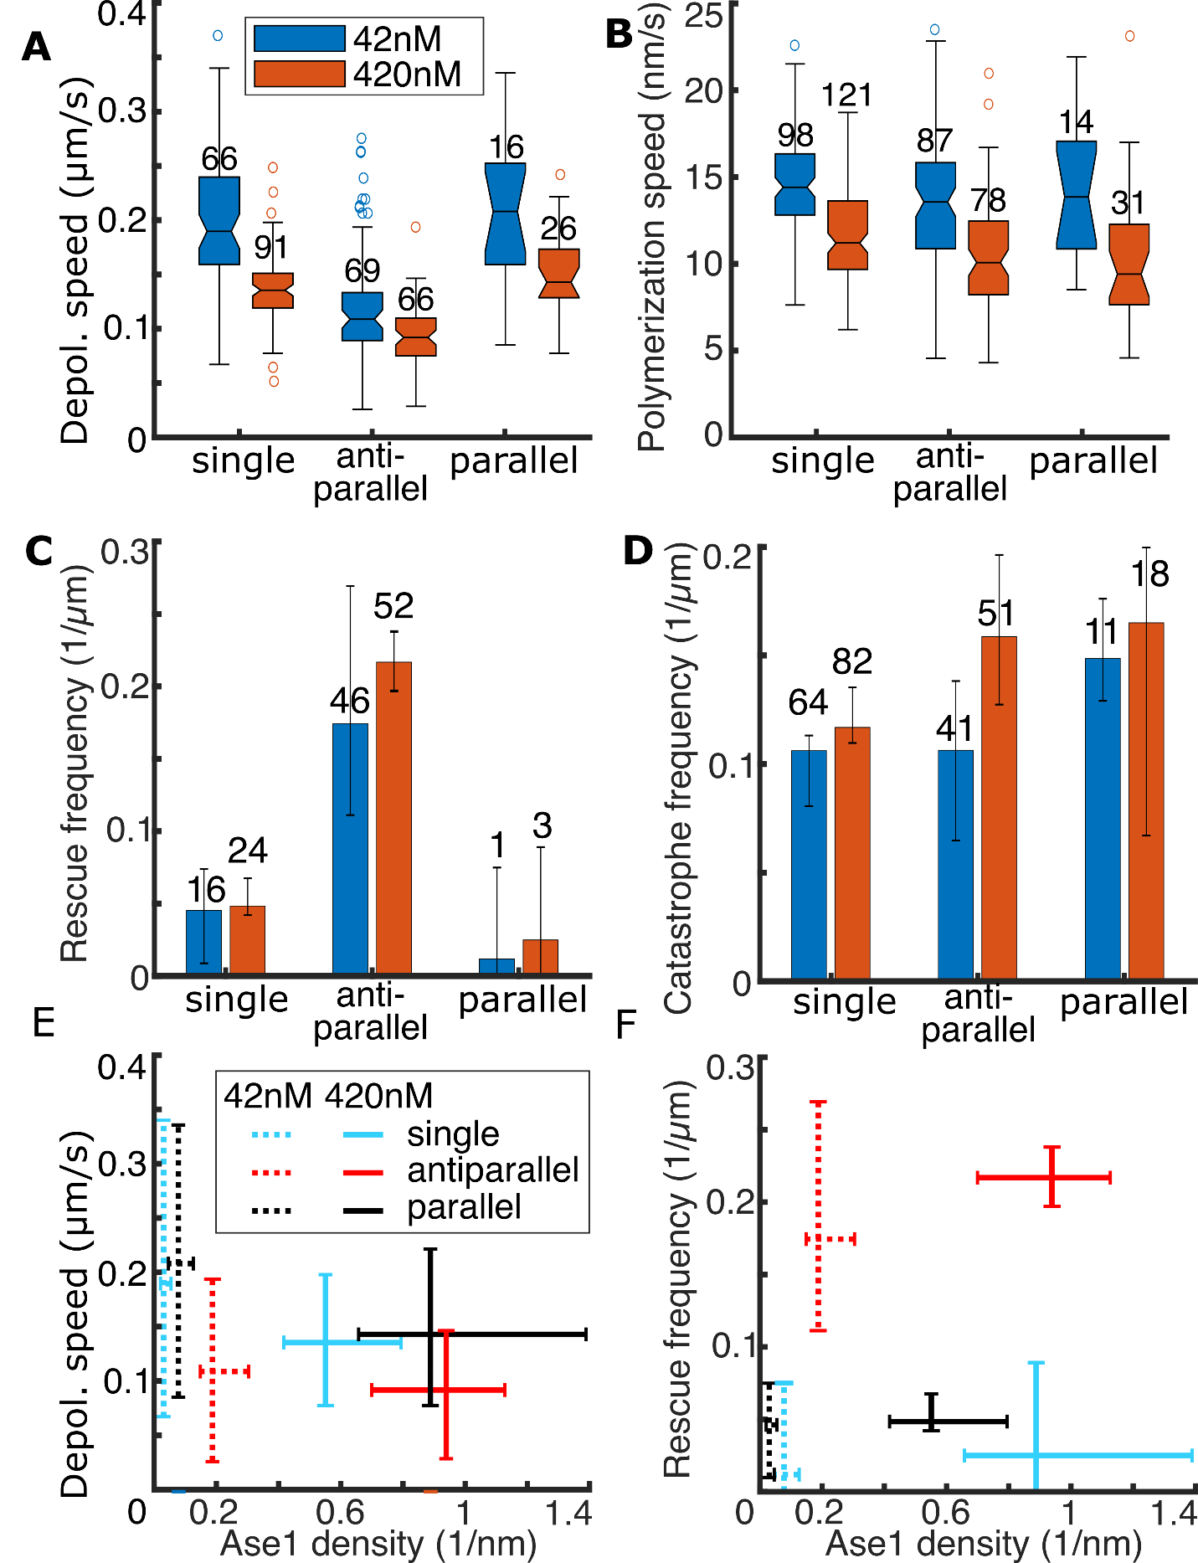

**Figure 2. Ase1 differentially regulates microtubule dynamics.**The depolymerization speed (**A**), polymerization speed (**B**), rescue frequency (**C**), and catastrophe frequency (**D**) of dynamic microtubule plus ends in different configurations and in the presence of 42 or 420 nM Ase1-neon. **E** The Ase1-neon density (see Figure 1F) versus depolymerization speed (see A). **F** The Ase1-neon density (see Figure 1F) versus rescue frequency (see C). All plots show results for the same experiments as shown in Figure 1.  Boxplots are weighted by the distance a microtubule tip covered during a sampled period of growth or shrinkage. In boxplots, the numbers indicate the number of samples, in bar plots, the numbers indicate the number of catastrophes or rescues. Further, in bar plots, the height of the bar indicates the catastrophe/rescue frequency as determined from all time lapses (number of total events divided by total distance covered), while the error bars indicate the lowest and highest frequencies as determined from each individual time lapse (Methods).

**Accumulation of Ase1 at the disassembling ends of shrinking microtubules reduces depolymerization velocities**(fig 3)

To investigate the mechanism of Ase1-dependent microtubule stabilization, we next examined Ase1 at microtubule ends. On growing plus ends, Ase1 did not exhibit any specific localization (Figure 1, Figure S3A). We observed however that Ase1 accumulated at depolymerizing microtubule tips, proximal of the retracting tips (Figure 3A-C). This accumulation, termed ‘protein sweeping’ or 'herding', is analogous to the *in vitro* behavior of kinetochore associated Ndc80 and Dam1 complexes, which can connect large objects, like µm-sized beads, to the ends of depolymerizing microtubules (Powers et al. 2009). Interestingly, protein accumulation at retracting microtubule ends may oppose MT depolymerization (Grishchuk et al. 2008)(REF Al-Hiyasat & Howard, arxiv 2022). Therefore, using a modified setup (see Methods), we performed further experiments to measure Ase1 accumulation at depolymerizing microtubule ends over time (Figure S3). We found that Ase1 accumulated within 20 seconds after catastrophe, after which Ase1 densities saturated (Figure 3D). The accumulation and the resulting elevated levels of Ase1 at the retracting microtubule tip coincided with a slowdown of depolymerization, both for isolated microtubules and antiparallel overlaps, with a stronger effect on the later ones (Figure 3E, S3A,B). For antiparallel overlaps, the local accumulation of Ase1 at the MT tip coincided with increased rescue rates (Figure 3F). In isolated microtubules and parallel overlaps, the rescue rate was too low to observe this correlation (Fig. 2c).

To exclude the possibility that Ase1 could bind to tubulin in solution and change the chemical equilibrium of MT assembly, or that it could bind directly to MT tips, we removed both Ase1 and tubulin from solution. As microtubules started to depolymerize Ase1 still accumulated at the depolymerizing ends, further indicating that this increase is due to sweeping of Ase1 molecules that were already bound to the microtubule lattice before catastrophe (Figure S3C). Occasionally, we observed that a depolymerizing MT tip would drag other microtubules, indicating that substantial forces could be transmitted by this mechanism (Figure 3G). This is analogous to Dam1/Ndc80 complexes, which can transmit microtubule depolymerization forces to large objects (Lombillo et al. Nature 1995). In summary, these experiments indicate that lattice bound Ase1 molecules are swept by the depolymerizing MT ends. The resulting specific accumulation of Ase1 at MT ends can then lead to their stabilization by decelerating depolymerization and promoting rescues.

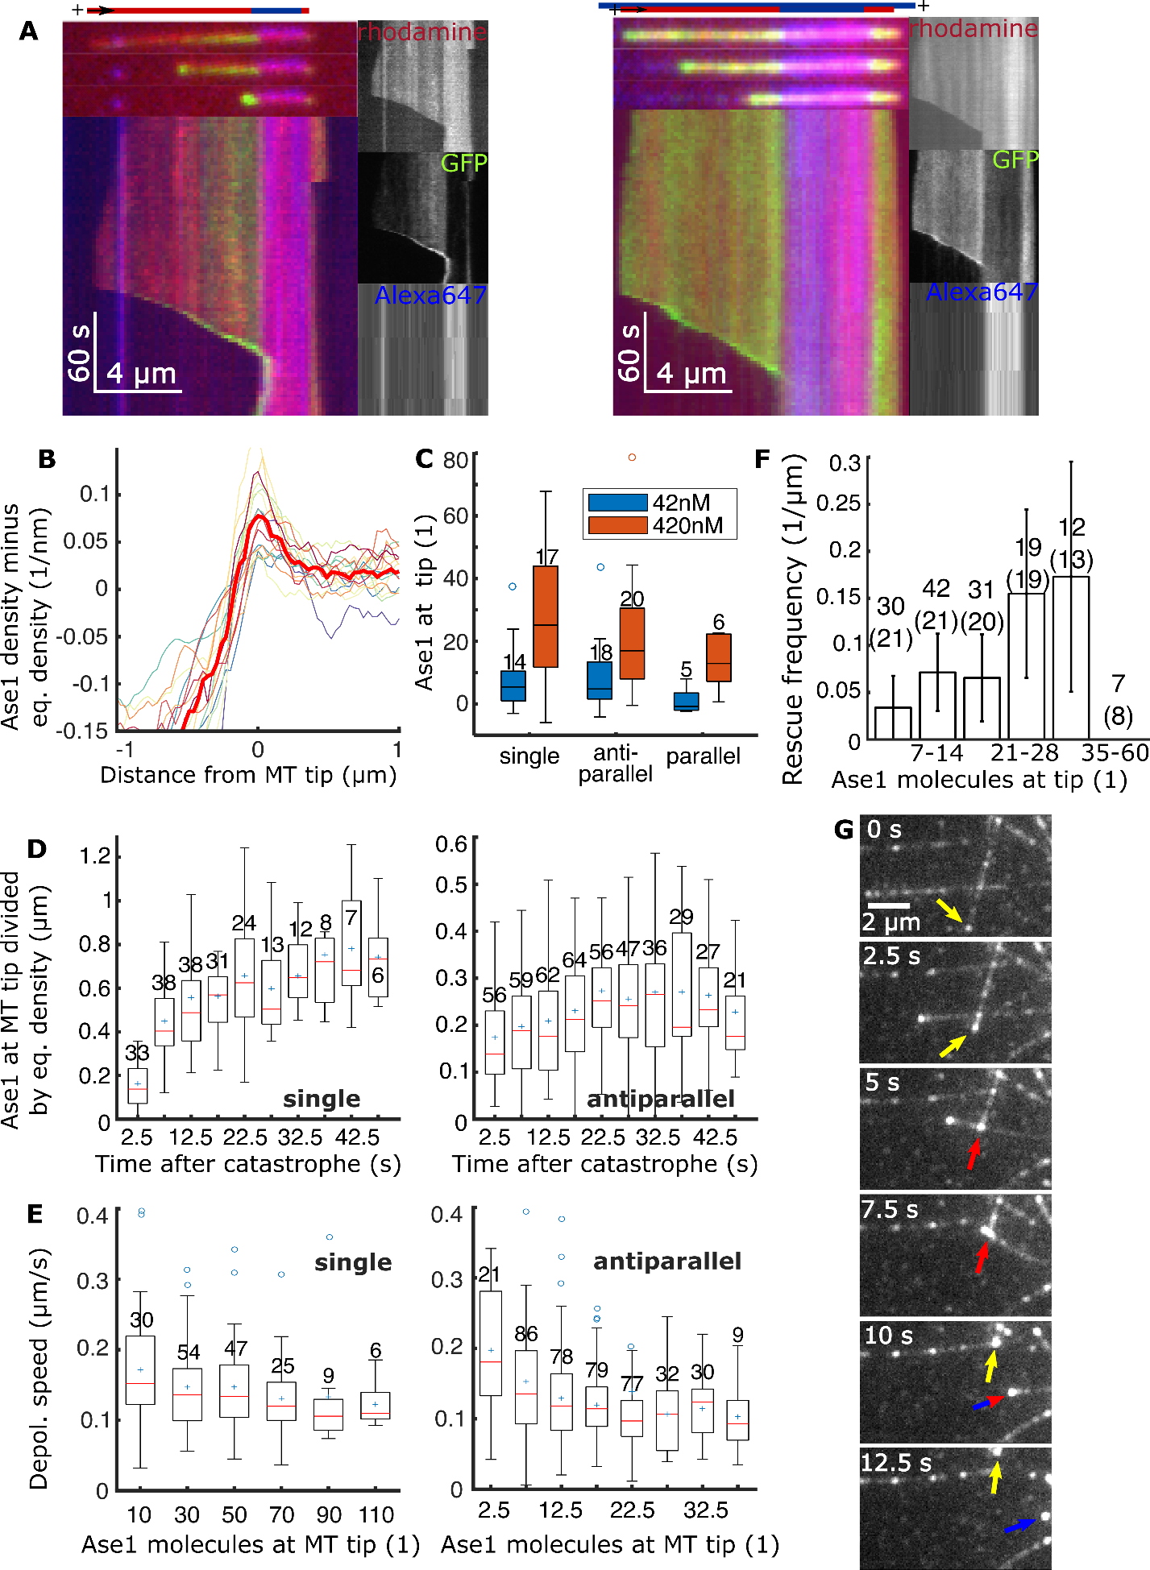

**Figure 3. Ase1 is swept by depolymerizing microtubule tips.  A**Kymographs of the plus end of depolymerizing single MTs at 6 nM Ase1-GFP in solution (left) respectively antiparallel MTs at 1 nM Ase1-GFP (right). These experiments were performed under slightly different conditions than those shown in Figure 1, 2, and 3B-C. The stabilized GMPCPP-microtubule seeds were labeled with 15% rhodamine and 15% Alexa647 (template microtubules as shown in the sketch for E were labeled with 1% Alexa647), while the free tubulin in solution was labelled with 7% rhodamine. In sketches, dynamic extensions with GDP lattices are colored red, and stabilized GMPCPP seeds are colored blue. The greyscale panels show the Alexa647 channel (bottom). **B**Plots showing the density of Ase1-neon around single MT tips during depolymerization at 420 nM, minus the equilibrium density (as determined by measuring the density at the respective spot on the microtubule before catastrophe). This density is shown as measured via our experimental setup, and thus blurred by the setup’s point spread function. Each colored thin line is the median signal distribution of one depolymerization event (median of all observed frames). The thick red line is the median of all the thin colored lines. Results from same experiments as analyzed in Figures 1, 2, and 3C. **C**Boxplot showing the estimated median number of additional Ase1 molecules at MT tips per depolymerization event, which was derived inferred from data as shown in A. Results from same experiments as analyzed in Figures 1, 2, and 3B.  **D** The y-axis shows the number of additional Ase1 molecules at the tip of depolymerizing MTs for single MTs (left) respectively antiparallel MTs (right), divided by the equilibrium density (as determined by measuring the density at the respective spot on the microtubule before catastrophe). The x-axis shows time passed since the catastrophe. Each data point represents data extracted from one line scan, the data points recorded during each event are connected by lines and share the same color. **E** Instantaneous depolymerization speed plotted over number of additional Ase1 molecules at the MT tip (the mean value of the two values recorded from the two frames which were used to compute the speed)**.** Data points recorded before 5 seconds after catastrophe were discarded as they were affected by limits in temporal resolution. **F**Rescue frequency plotted over number of additional Ase1 molecules at the MT tip. The distance depolymerized at a respective x-value was added to the respective bin. The number of rescues observed in the same bin (N) was then divided by the sum of depolymerized distances (shown in µm, the number in parentheses refers to the number of microtubules) to yield the rescue frequency. The width of the error bars was obtained by dividing the square root of the number of rescues by the sum of the depolymerized distances. **G** A time series of micrographs (Ase1-GFP channel) showing an event where the accumulated Ase1 at one depolymerizing microtubule tip (indicated by yellow arrows) causes the tip to “drag” a microtubule it crosses with it, thereby bending it. In the frames where bending occurs, the arrows are colored red. The blue arrows indicate the (depolymerizing) end of the formerly bent microtubule. Same experiments as shown in S3C.  Results shown in A and D-F are from a different dataset than results shown in Figures 1, 2, and B,C (see Methods).

**Biased diffusion at depolymerizing microtubule tips explains Ase1 sweeping** (fig. 4)

To analyze how Ase1 accumulates at shrinking microtubule ends, and the effects this has on shrinkage speed, we considered a one-dimensional microtubule made of lattice sites corresponding to tubulin heterodimers, starting at the plus end (see Methods). Although it includes a single microtubule, this model is applicable to antiparallel pairs, by adapting the on/off rates of Ase1 binding to the lattice. Events such as Ase1 binding, unbind, and hopping to neighboring sites are stochastic with constant rates $k_{on }, k_{off}, k_{h}$ (Fig. 4A) that were determined experimentally (see Table S1). Importantly, only one Ase1 molecule can be attached to any one tubulin heterodimer, and Ase1 can thus only hop to unoccupied neighboring sites. We also assume that Ase1 does not fall off from the microtubule by hopping at its plus ends, as shown experimentally (Fig. 4A, red arrow on the left)(refs). MT shrinkage is also modelled stochastically by detachment of the terminal subunit, at a rate that is affected by Ase1 (Fig. 4B top). Specifically, this rate is $k_{d}^{0}$ when the first tubulin subunit is free of Ase1, and $k_{d}={(1-Ω)k}_{d}^{0}$, if Ase1 is bound at the terminal site. The value of $k_{d}^{0}$ is set by the mean depolymerization speed measured *in vitro* without Ase1 (Table S1). The parameter $Ω∈[0,1]$ specifies the effect of Ase1 on disassembly (Fig. 4B bottom). If $Ω=0$, Ase1 has no effect, while if $Ω=1$, the terminal subunit cannot unbind if Ase1 is bound. For any value $Ω>0$, this simple model leads to an accumulation of Ase1 near the shrinking tip and a concomitant decrease of the shrinkage speed (Fig. 4D, S4A). The accumulation occurs because subunits without Ase1 are more likely to be lost at the plus-end, so depolymerization increases the density of Ase1 at the shrinking end. At steady state, the system can be characterized by the probability $P_{1}$ of the terminal site to be occupied, and the rate of subunits loss is ${k_{d}=k}_{d}^{0}(1-ΩP_{1})$.

Since all parameters of this model (Model 1) were set from experimental measurements, except for $Ω$, we first tested whether any value of $Ω$ could quantitatively recapitulate the experimental behavior. Specifically, we aimed to reproduce the timescale of accumulation of Ase1, and the total amount of Ase1 accumulated and shrinking speed reached at steady state (Table S2). For $Ω=1$, the model predicted shrinkage speeds that are comparable to the experimentally observed ones (Fig. 4E), but when comparing the timescale and number of Ase1 molecules accumulated at steady state we found that they were respectively 2.5× and 8× higher than experimentally observed (Fig. 4F, G). Therefore, despite recapitulating the experimental phenomenology qualitatively (Fig. 4D), this first model was insufficient to quantitatively reproduce our experimental results.

The failure of Model 1 indicated that Ase1 should affect microtubule shrinkage at lower density. We thus hypothesized that Ase1 molecules located at lattice sites other than the terminal one could affect shrinkage. We initially tested the possibility that the rate of tubulin subunits loss at the plus end would be reduced by a factor $(1-Ω)$ if any of the $N$ terminal sites were occupied (Fig. 4C). This rate at steady state would then be $k_{d}=k_{0}^{d}[1-Ω\{1-\prod_{i=1}^{i=N}{}(1-P_{i})\}]$, where $P_{i}$ is the probability of site $i$ being occupied by Ase1. For $N=4$ and $Ω=0.9$ this model (Model 2) reproduced microtubule growth speed at steady state and accumulation timescale, but the accumulation of Ase1 at steady state was more than double of the experimentally observed (Fig. 4E-G). Higher values of $N$ gave improved fit to the experiments, but it is unclear how Ase1 could influence the unbinding of the terminal tubulin heterodimer from a distance. Instead, it seemed more natural to assume that Ase1 molecules in neighboring protofilaments would also affect the unbinding, since they are closer. To avoid the complexity of modelling the 13 microtubule protofilaments with their longitudinal offset, we turned to a phenomenological model (see Methods) in which the rate of loss of subunits at the plus end is $k_{d}=k_{0}^{d}[1-Ω\{1-\prod_{i=1}^{i=N}{}{\left(1-P_{i}\right)}^{3}\}]$. Here, the exponent 3 represents the number of protofilaments that are considered sufficiently close to affect depolymerization of one protofilaments (*i.e.* this protofilament, and the two flanking ones). This model (Model 3) with $Ω=0.84$ produced the best agreement with the experimental data from single microtubules (Fig. 4E-G). The data from crosslinked microtubules could be reproduced by reducing the diffusion rate of Ase1 (VALUE) and its unbinding rate (VALUE) (Fig. 4SXX), following the experimentally known retention and slower diffusion of Ase1 in microtubule overlaps (refs).

In summary, stochastic modelling of the system showed that the observed effects of Ase1 on shrinking microtubule ends could be explained simply. The failure of the simplest model suggested that Ase1 acts cooperatively near the terminal tubulin units. Modifying the assumptions in this direction indeed improved the agreement obtained, coming close to reproducing the experimental data quantitatively. The effects of Ase1 on microtubule shrinkage speed and the timescale and extent of the accumulation of Ase1 molecules could all be reproduced within a factor 2.

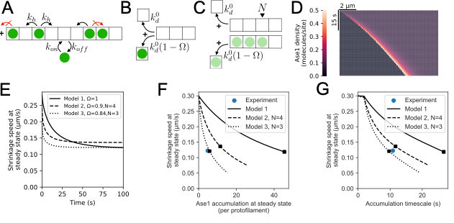

**Figure 4. Biased diffusion can explain Ase1 sweeping at depolymerizing microtubule tips.** (A-C) Cartoons representing the model. (D) 50 seconds of kymographs generated from Model 1. (E) Shrinkage speed in time for the different models, for the parameter sets that fit the simulations. (F-G) The “experiment” dot is placed at the measured value of each magnitude along the x and y axes. The lines represent all the solutions of Model 1,2,3 from omega=0 to omega =1. The square is the best value of omega. This value of omega is the one used to plot the dynamics of shrinkage speed in (E).

Discussion

In this work, we investigate the effects of the diffusible microtubule crosslinker Ase1 on microtubule depolymerization, both when crosslinking microtubules and on individual microtubules. Our results show that Ase1 decreases microtubule depolymerizing velocities, and, by selectively promoting the rescue frequencies of microtubules in antiparallel overlaps, selectively stabilizes antiparallel overlaps, while not substantially affecting the stability of parallel overlaps or single microtubules. In bipolar microtubule arrays, like mitotic spindles, this attribute of Ase1 can enable selective stabilization of the array’s central regions, while keeping the rest of the array dynamic and pliable. We imaged Ase1 sweeping, the accumulation of lattice-bound, diffusible Ase1 in front of the retracting tips of depolymerizing microtubules, and found that accumulated Ase1 can transduce forces to other microtubules. These features, similar to those of the conserved kinetochore-localized Dam1- and Ndc80- complexes, which crosslink chromosomes to depolymerizing microtubule ends (Grishchuk et al. 2012, Grishchuk 2017) (Franck NCB 2007 ndc80 refs), indicate that, analogously to Dam1- and Ndc80- complexes, Ase1 accumulation at depolymerizing microtubule ends, antagonizes the dissociation of tubulin subunits from these microtubule ends. While on individual microtubules this effect may be overcome relatively easily, either by Ase1 dissociation (unbinding) or translocation (biased diffusion), both options happen less readily within overlaps, where Ase1 diffusion velocities and unbinding rates are greatly reduced (Kapitein et al. 2008)(Lansky Cell 2015), due protein avidity resulting from the multivalent interactions of Ase1 with the microtubules (Erlendsson Front. Mol. Biosci 2021; Braun J Cell Sci 2020). We propose that, similarly to Dam1- and Ndc80- complexes whose rescue-promoting propensity can be enhanced by putting load on the complexes (Franck et al. 2007) REFs, crosslinking Ase1 proteins may stabilize depolymerizing microtubules, because the individual protofilaments, force-coupled to the other microtubule by the Ase1 crosslinker, in order to bend into the rams horn formations associated with depolymerization, will have to work against the lattice of the other microtubule and thus will be stabilized. Our modeling predicts stabilization of adjacent protofilaments, which might be explained by Ase1 binding to a tubulin dimer allosterically stabilizing the adjacent protofilament either by Ase1's intrinsically disordered N-terminus directly binding to the adjacent protofilament (REF Subramanian) or indirectly through the tubulin lattice, such as kinesin-1 (REF Peet Cross, Nat Nanotech 2018; Morikawa, EMBO J 2015). Importantly, this scenario applies only to antiparallel microtubule overlaps, as for parallel overlaps no stabilizing effect additional to the one observed on single microtubules arises, indicating that the force-coupling is weak. This is consistent with the fact that Ase1 binds with much lower affinity to parallel, compared to antiparallel microtubules. Nevertheless, the mere presence of Ase1 on the lattice of individual microtubules is sufficient to reduce depolymerization velocities. This finding is consistent with the observation that single Dam1 complexes are sufficient for tracking of depolymerizing microtubule ends and for the force coupling of large beads to depolymerizing microtubules, while the formation of rings of Dam1 complexes is not required for these processes (REF).

The diffusive motion of Ase1 along the microtubule lattice is biased by the disassembling microtubule tip suggesting that for a single Ase1 molecule on an empty microtubule, the energy barrier to hop to an adjacent binding site is much lower than the barrier for Ase1 to fully dissociate from the microtubule. Our findings thus suggest that any molecule capable of diffusing on microtubules can exert forces on objects that the molecule has affinity for on accessible regions. It bears noting however that the transversal microtubule bending which we observed merely requires sub-pN forces (Kurachi et al. 1995). Thus, it may be interesting to measure the forces which Ase1 sweeping is capable of transducing, which would also shed light on the question on whether protofilament powerstrokes are an important component of Ase1 sweeping.

For actin filament overlaps, it has been observed that F-actin crosslinkers slow down actin depolymerization (Maul et al. 2003, Schmoller et al. 2011), suggesting that crosslinker dependent stabilization of filaments may be a fundamental mechanism, widespread across cytoskeletal systems.  We show that a  simple biased diffusion model can recapitulate many of the features of our observations in respect to the sweeping of Ase1 we observed, including the reduced depolymerization velocity. However, this does not rule out the possibility that the major cause for Ase1 sweeping during microtubule depolymerization could also be powerstrokes by bending protofilaments, which has been suggested to be a necessary component of Dam1 sweeping (Grishchuk et al. 2012).

Earlier study on a plant Ase1 analogue, MAP65-1 found increased rescue rates of microtubules within bundles compared to single microtubules. This study theoretically predicted that parallel bundles should display more rescues than single microtubules and that antiparallel bundling should induce more rescues than parallel bundling. This study, however, did not experimentally distinguish between parallel and antiparallel bundles (Stoppin-Mellet et al. 2013). Our methods allowed us to directly distinguish between different bundling orientations, where we did not observe parallel bundles to display more rescues than single microtubules. This shows that the ability of Ase1 to withstand “microtubule zipping” can be very specific to antiparallel bundles, however, our results do not rule out that under different (experimental) conditions Ase1 may also stabilize parallel bundles to some degree.

Our results show that the presence of diffusible microtubule crosslinkers can suffice to establish enduring antiparallel microtubule overlaps, such as found in the midzone of mitotic spindles. In such context Ase1 can work cooperatively with other microtubule rescue factors such as CLASP (Bratman et al. 2007) or provide an alternative mechanism for selective life time enhancement of antiparallel overlaps. We speculate that the impact of diffusible crosslinkers on microtubule dynamics may be tunable by posttranslational modifications of either the crosslinkers or the microtubule surface. Such a tunability has recently been proposed for a seemingly related capacity of Ase1, namely the braking of microtubule sliding caused by molecular motors (Thomas et al. 2020) (REF Fu, C., Ward, J.J., Lo ̈ıodice, I., Velve-Casquillas, G., Nedelec, F.J., and Tran, P.T. (2009). Phospho-regulated interaction between kinesin-6 Klp9p and microtubule bundler Ase1p promotes spindle elongation. Dev. Cell 17, 257–267.).

# Supplementary figures

**Figure S1. A** Bundling probability for when microtubule plus ends encountered other microtubules, in either parallel or antiparallel orientation, versus the angle of incidence (results pooled for all Ase1-neon concentrations). The outer number denotes the number of recorded crossings at the respective angle, while the inner number denotes the number of bundling events.

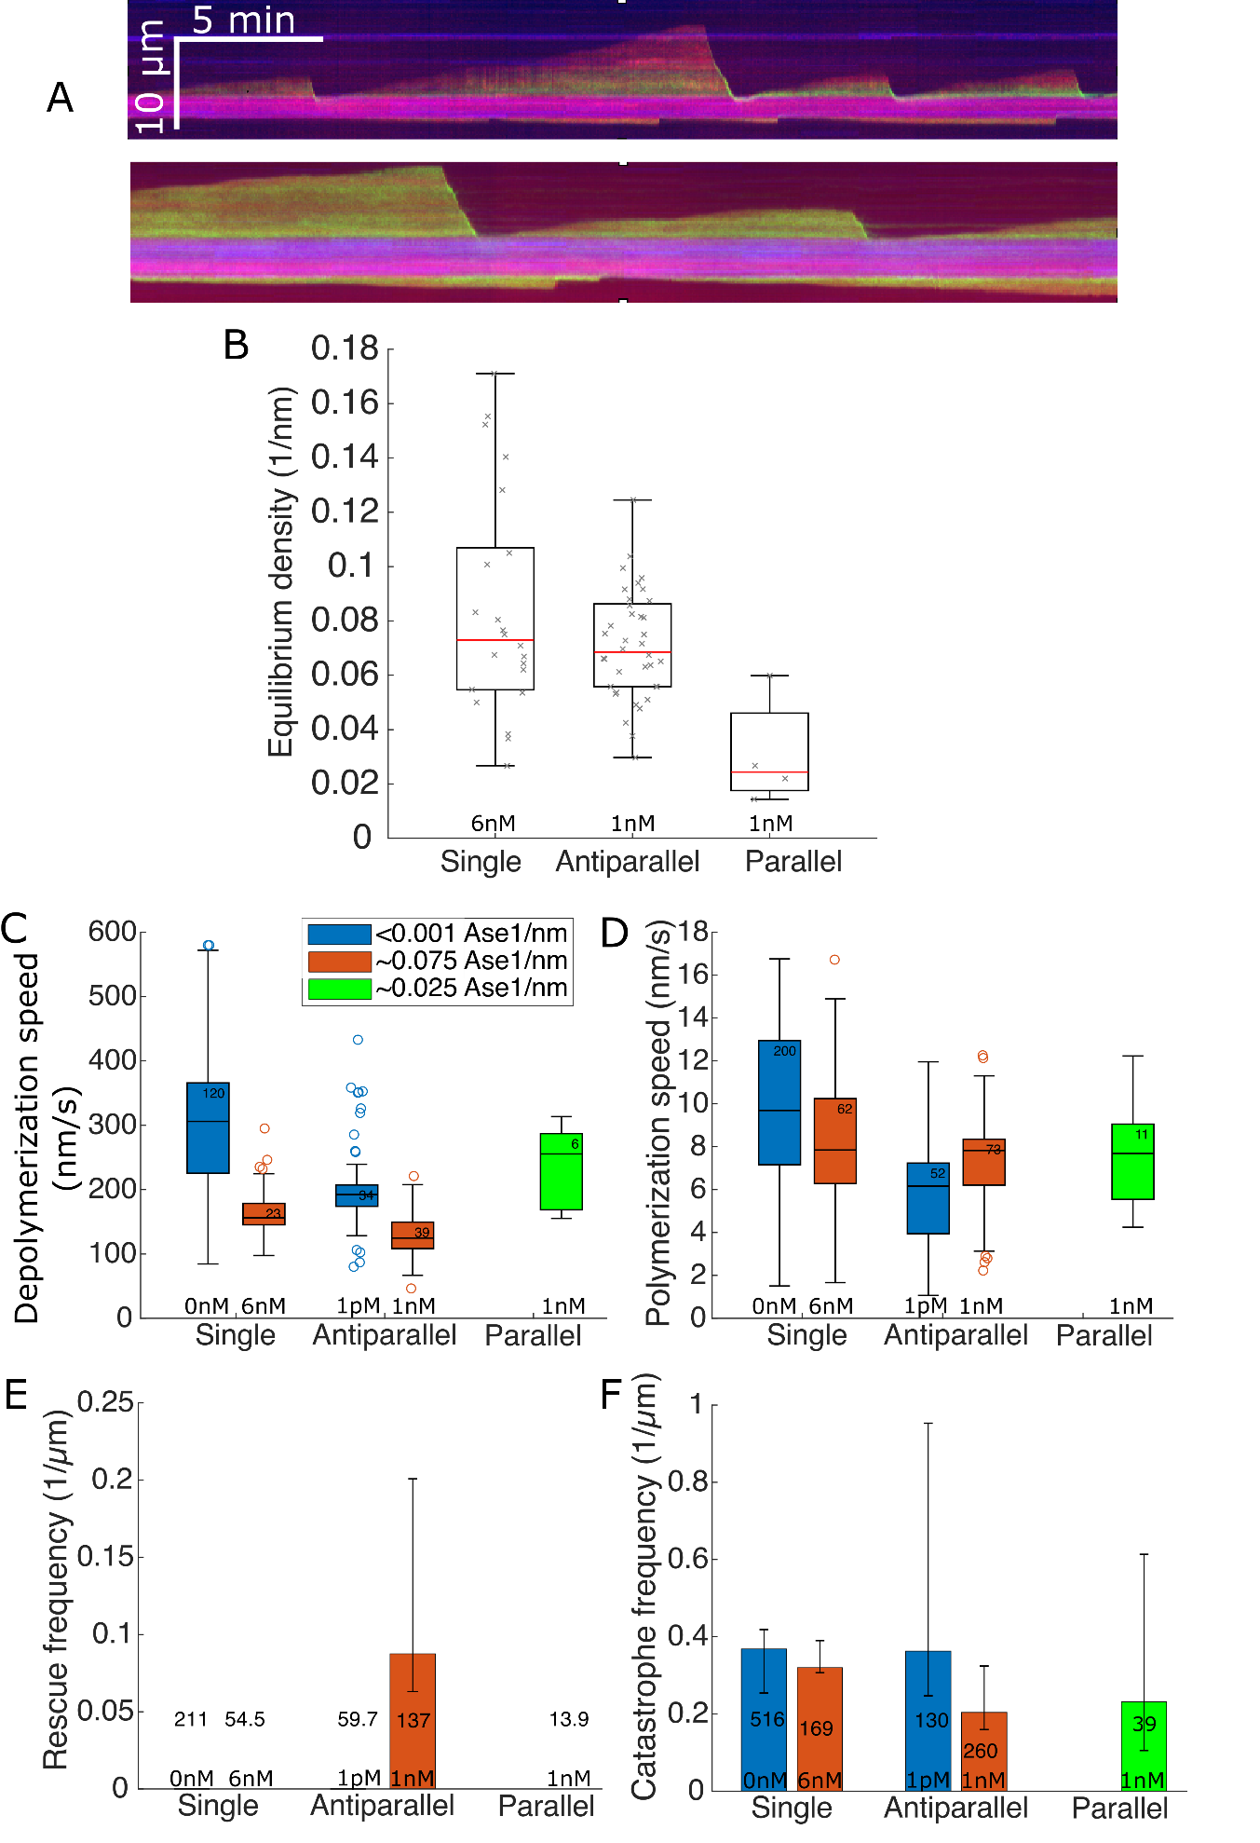

**Figure S2. A** Full kymographs of same microtubules as shown in Figure 3A. **B** Equilibrium density on microtubules and within overlaps for the set of experiments which is evaluated in Figure 3C-G. **C-F** The depolymerization speed (**C**), polymerization speed (**D**), rescue frequency (**E**), and catastrophe frequency (**F**) of the dynamic microtubule plus ends for a set of experiments with slightly different experimental parameters from the experiments whose results we present in the main figures (see Methods). In this set of experiments, both single microtubules and antiparallel overlaps displayed a similar steady-state Ase1 density, which was achieved by adding more Ase1 to the assay solution where we analyzed the dynamics of single microtubules. The numbers in the boxes in C+D represent the number of shrinking respectively growing periods analyzed, the numbers in E+F represent the total amount of µm shrunk which had been analyzed. Boxplots are weighted by the distance a microtubule tip covered during a sampled period of growth or shrinkage. Further, in bar plots, the height of the bar indicates the catastrophe/rescue frequency as determined from all time lapses (number of total events divided by total distance covered), while the error bars indicate the lowest and highest frequencies as determined from each individual time lapse.

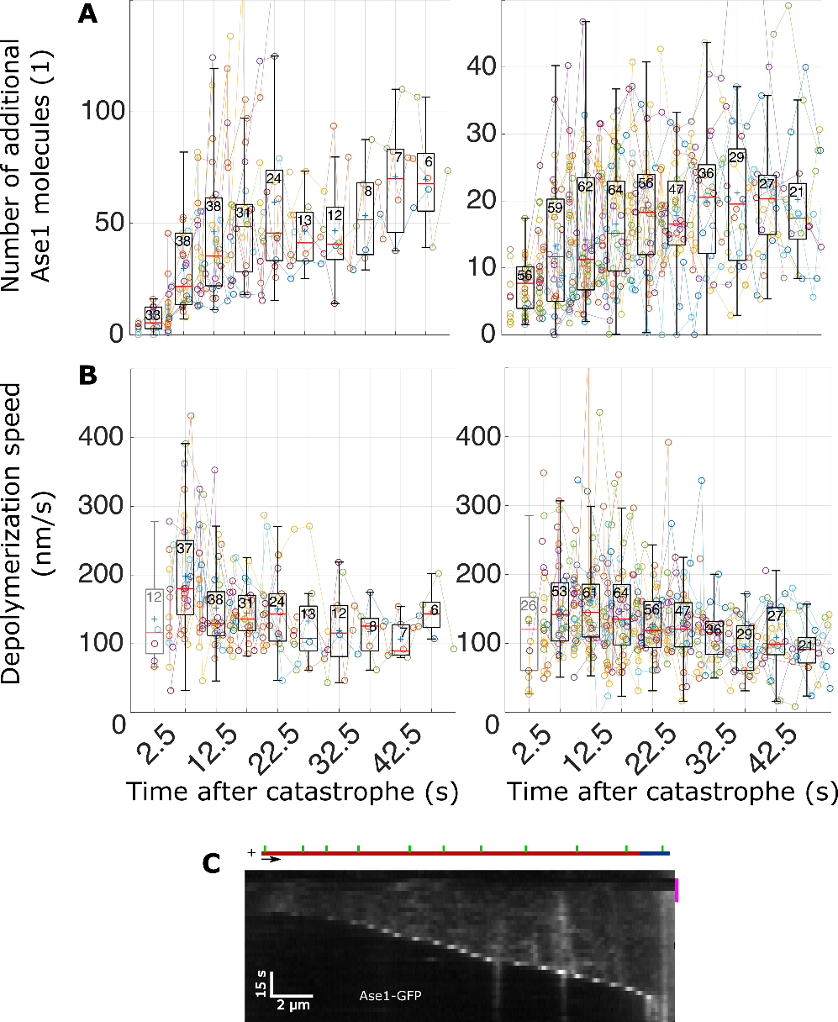

**Figure S3. A** The number of additional Ase1 molecules at the tip of depolymerizing microtubules for single microtubules (left) respectively antiparallel microtubules (right), plotted over the time passed since the catastrophe, for the set of experiments as shown in Figure 3C-F. Each data point represents data extracted from one line scan, the data points recorded during each event are connected by lines and share the same color. [% analysis as performed for Figure 2A-D %] **B** The frame-to-frame depolymerization speed of microtubules over time, for experiments as shown in Figure 3C-F (analogous to A). Because the exact time of catastrophe is unknown due to limits in temporal resolution, the velocity measurement right after catastrophe underestimates the actual velocity. **C** [%This is very hard to read (as in: unintuitive). Do we have an example with higher frame rate – showing Ase1 as continuous line of increasing intensity in the kymograph? %] In this experiment, Ase1 and tubulin had been removed from the assay buffer during the time frame indicated by the pink bar next to the kymograph, prompting subsequent microtubule depolymerization and concomitant Ase1 accumulation at the tip. Same assay buffer as in Figure 3C-F, data from same experiments as shown in Figure 3G.

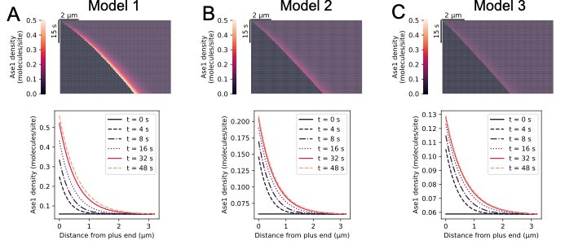

**Figure S5**

Simulated kymographs from each model, and density of Ase1 along the microtubule.

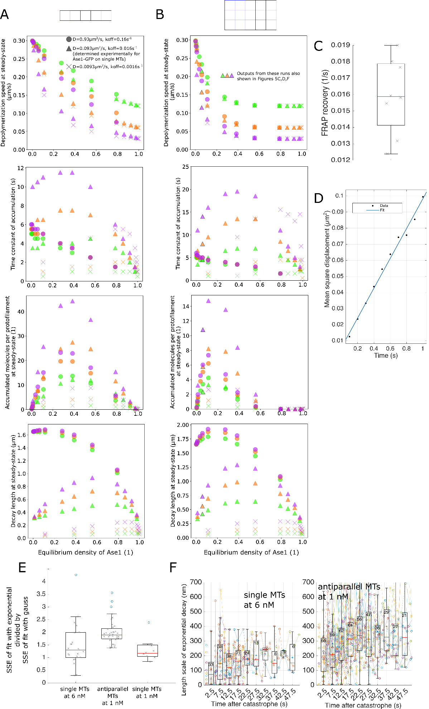

**Figure S4. A** Modeling results for steady-states, for the model where only the terminal tubulin of the protofilament affects depolymerization (see text). **A** Modeling results for steady-states, for the model where depolymerization is also affected if any neighboring tubulin is occupied (see text). The upper panel is identical with Figure 5E. **C** RecordedFRAP recovery times on single microtubules (see Methods) – the median value was used as koff for modeling. **D** Mean square displacement of single Ase1 molecules diffusing on single microtubules during the first second (see Methods) and fitted line – the slope of the fitted line was used as D for modeling (number of molecules = 2008). **E** The sum square error (measured within the fitted region, i.e., the region between the two local minima around the local Ase1 density maximum) of fitting a right-sided exponential decline divided by the sum square error of fitting a gaussian distribution (with bounds for sigma between 180 and 450 nm). A value higher than 1 indicates the that the signal had a gaussian shape rather than an exponential shape. The equilibrium density was assumed to drop abruptly to zero at the microtubule tip, and removed from the signal before fitting (see Methods). This step function, as well as the right-sided exponential decay, were convolved with a gaussian to simulate the point spread function of our setup (a gaussian with a sigma between 180 and 190 nm, see Methods). Data points represent median values of fits obtained during one depolymerization event. **F** Fitted values for the length scale of the exponential decay (exp(-x/length scale)) over time. Representation analogous to Figure 4B-D.

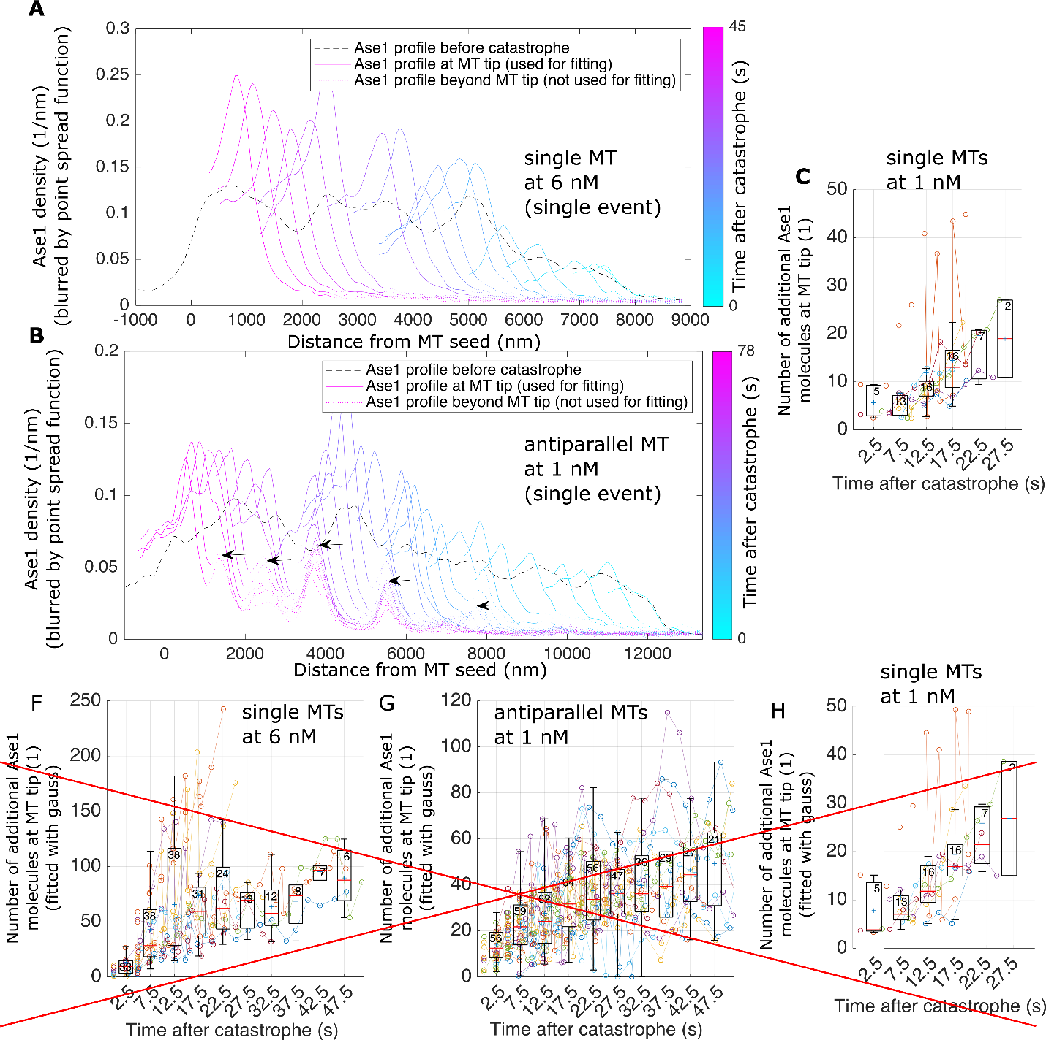

**Figure S5. A** The Ase1 density along a single microtubule before (black) and during (colored) a depolymerization event. The color of the line indicates the time after catastrophe when the respective profile was recorded, where the dotted region was excluded from the fit. For readability, the Ase1 density in the region left of the local minimum left of the microtubule tip is not shown (the Ase1 density in that region was not used for fitting either). **B** Same representation as A, for an antiparallel microtubule. The arrows indicate regions where Ase1 did not immediately leave the surface, and presumably remained bound to the template microtubule (the microtubule the depolymerizing microtubule was crosslinked to). **C** Same representation as in Figure S4A, for single microtubules at 1 nM Ase1.

|  |  |  |
| --- | --- | --- |
| Parameter | Value(s) | Source |
| microtubule depolymerization speed at 0 Ase1 | k0d = 300 nm/s | Figure S4A (leftmost box) |
| Ase1 off-rate | koff = 0.016 s-1 | Figure S4C |
| Ase1 diffusion coefficient | D = 0.093 µm2/s | Figure S4D |
| Ase1 on-rate | kon = 0.001 s-1 | Not directly measured. on-rate of 0.001 s-1 matches single microtubule density, while ~0.02 s-1 matched overlaps (compare Figure 4E, Figure S2B) |
| Tubulin dimer/binding site length | 8nm | The anatomy of flagellar microtubules: polarity, seam, junctions, and lattice.  JCB 1995 |

**Table S1.** Input parameters for model.

# Methods

Protein purification. Ase1-GFP was expressed and purified as described previously (Janson et al. 2007). Ase1-neon was expressed blabla. Ase1-neon was used for the set of experiments as analyzed in Figure 1+2+3C,D,E (“set A experiments”), Ase1-neon for experiments as analyzed in Figure 3A,F,G (“set B experiments”).

In vitro tau-microtubule binding assay. Microtubules and flow cells were prepared as described previously (Braun et al. 2011). Biotinylated, GMPCPP-stabilized, fluorescence-labeled microtubules in BRB80 (80 mM Pipes/KOH pH 6.9, 1 mM MgCl2, 1 mM EGTA) were immobilized in a flow chamber using biotin antibodies (Sigma B3640, 20 µg ml−1 in PBS). Subsequently, the buffer in the flow cell was exchanged for assay buffer (see below). Then, Ase1 in assay buffer was flushed into the flow cell at the final assay concentration stated in the main text, together with tubulin. Set A experiments were performed at room temperature and with 30µM unlabeled tubulin present in solution. Set B experiments were performed at 29°C and with 14µM tubulin, 7% of which was labeled with rhodamine. In the case of set B experiments, non-biotinylated GMPCPP-stabilized microtubules were flushed into the flow cell and bound to the template microtubules that were sparsely covered sparsely with Ase1 (these steps were performed before the assay buffer had been flushed in).

Assay buffer. The following buffer components common to all used buffers: 20mM PIPES pH 6.9, 10mM HEPES pH 7.2, 0.5mM EGTA, 1mM MgCl2, 0.5mM Mg-ATP, 0.67mM GTP, 0.67% Tween20, 6.7mM DTT, 0.3 mg/ml Casein, 13.5mM D-Glucose, 0.3mg/ml glucose oxidase and 0.03mg/ml catalase. The buffer for set A experiments, in addition to these components, contained 70mM KCl, and 0.1% Methylcellulose, 0.1% Glycerol, 1mM sodium phosphate and 1µM ATP. The buffer for set B experiments, in addition to the components common to all buffers, contained 116mM KCl and 0.065% Methylcellulose.

Imaging. Labeled proteins were visualized sequentially by switching between the corresponding channels (Chroma filter-cubes) using Nikon-Ti E microscope equipped with 100x Nikon TIRF objective in combination with a Hamamatsu Orca Flash 4.0 sCMOS camera (set A experiments) or 63x Zeiss oil immersion TIRF objective in combination with a Andor Ixon DV 897 (Andor Technology) EMCCD camera (set B experiments). The acquisition rate was 5 seconds for set A experiments and 2.5 seconds for set B experiments, the exposure time was 100ms for both cases. For set B experiments, the Alexa647-labeled microtubule seeds were imaged before the start of the time lapse, and only the Ase1-neon channel was imaged during the time lapse. For set B experiments, the rhodamine (tubulin) and the GFP (Ase1) channel where imaged sequentially, whereas every 40th frame the Alexa647 channel was imaged in place of the GFP channel, in order to track the location of the GMPCPP-stabilized seeds (which we with this data determined to not move significantly during experiment time).

Image analysis.Data was analyzed using FIJI 1.52 (Schindelin et al. 2012) and custom-written Matlab (Mathworks) routines.

*Overlap lifetime estimation.* The lifetime of regions of microtubule overlap was estimated for two different configurations: Antiparallel “midzones”, where two dynamic extensions met and formed a dynamic “midzone” (as shown in Figure 1B), and parallel bundles of two dynamic extensions (as shown in Figure 1D). For both antiparallel midzones and parallel bundles, lifetime was taken to start upon the dynamic (GDP) lattices of each involved microtubule being crosslinked (for antiparallel configurations, we additionally required both plus ends to be within 3 microns to each other upon start of the event), and to end upon one of the involved microtubules to shrink back to its GMPCPP-stabilized region. Additionally, for antiparallel bundles the lifetime also ended upon the midzone ceasing to exist. If an overlapping region survived until the end of the recorded time-lapse movie, the event was registered as censored. Figures 1E+F were generated by using the Matlab function ecdf with setting “survival”.

*Parameters of microtubule dynamics* have been estimated by generating kymographs and approximating the location of microtubule plus ends over time and space with straight lines (for set A experiments, the Ase1-neon signal was used to visually track microtubule ends, as microtubule were not imaged directly). This directly yielded polymerization and depolymerization speeds. Rescues were identified as events where a microtubule switches from shrinkage to growth before reaching the GMPCPP-stabilized seed, and catastrophes were events where growth was followed by shrinkage. Rescue and catastrophe rates were estimated by dividing the number of rescues respectively catastrophes by the sum of the total distance shrunk respectively grown by all plus ends.

*Single fluorophore quantification.* Fluorescent signal of a single Ase1-neon dimer was determined by generating intensity time-traces of Ase1-neon molecules and estimating the height of the occurring steps in change of intensity (only small steps, i.e., steps likely to be bleaching steps). The number of steps was first estimated by eye, and this number was used as input for the *findchangepoints* function of Matlab to determine the position of the steps (by detection of significant changes of the mean value). To yield the intensity per Ase1 dimer, the median of the heights of these steps was calculated and multiplied by two. For the estimation of single Ase1-GFP dimers, the intensity of single diffusive spots of GFP signals on microtubules has been taken at very low concentration of Ase1-GFP in the buffer (no bleaching data available for these experiments). For estimation of single fluorophores for set B experiments we did not have bleaching data available, instead we measured the intensity of diffusing molecules (which may overestimate the intensity per single molecule).

*Ase1 density estimation.* Area selections along the microtubule length (only regions with at least one dynamic extension present were measured) were used to read out the mEGFP or mCherry fluorescent signal and to estimate the integrated signal intensity of GFP- or neon-labeled Ase1 bound to the microtubule. The signal in regions directly adjacent to the microtubule was subtracted as background signal. The density of GFP- or neon-labeled Ase1 bound to the microtubule was then estimated by dividing the integrated intensity by the estimated intensity per single fluorescent molecule (either GFP or neon, see below) and the length of the region.

*Estimation of amount of Ase1 being swept.* To estimate the number of swept Ase1 molecules for Figure 3, we first obtained density traces for each frame during a microtubule shrinkage period. These traces were obtained by summing the pixel intensities perpendicular to the microtubule. For each frame f we analyzed the corresponding density trace Df as follows. (1) We computed Ds by subtracting the density trace Dbefore_catastrophe of the microtubule before the catastrophe had occurred from Df (Ds = Df - Dbefore_catastrophe) (2) We obtained x = 0 = XDsmax, the location of the local maximum of Ds in vicinity of the microtubule plus end. (3) We obtained XDsright by finding the first local minimum of Ds to the right of XDsright (to reduce the effect of noise, we smoothed Ds for this computation). “Right” of Ds, in our chosen coordinate system, means toward the microtubule seed (x > 0). (4) XDsleft = XDsmax – 471nm (471 nm = 3 pixels). (5) We computed DA. DA is equal to Df to the left of XDsmax, and equal to Ds + Df(XDsmax) – Ds(XDsmax) to the right of XDsmax. (6) We fitted a distribution YF (shape see below) plus an error function YE to DA between XDsleft and XDsright. We required both YF and the error function to not have any x-offset: YF was a right-sided decaying exponential exp(-x/ λ) (YF = 0 where x < 0, and with λ bounded between 1 and 1000 nm) convolved with a gaussian exp(-x2/ 2σ2) (with σ bounded between 180 to 190 nm to account for the point spread function of our setup; this same σ had been used as input for YE). Instead of a blurred right-sided decaying exponential, we for some figures (Figure S5F-H) used a gaussian exp(-x2/ 2σG2) for YF (with a σG between 180 nm and 450 nm, which was independent of the σ used for YF). We also fixed G+E (plus a constant value) to approach the minimum of DA to the left of the tip, and the average of DA to the right of XDsright (the average of DA within 5 microns from XDsright, giving more weight to values close to XDsright). (6) We then summed the Ase1 density below YF (as discretized in x by the pixel size), which we took as a proxy for the number of swept Ase1-GFP molecules after dividing by the intensity per Ase1 dimer (obtained as described above).

*Fluorescence recovery after photobleaching (FRAP) experiments.* Biotinylated GMPCPP-stabilized microtubules were immobilized on the coverslip. We then flushed in the same assay buffer as for set A experiments, incubated until the Ase1 density on microtubules reached a steady-state, and subsequently bleached Ase1-neon molecules and recorded the recovering Ase1-neon signal. We fitted the resulting recovery curve to the expression Ds – c * exp(-b*t), where Ds is the steady state density, and c and b are fitting parameters.

*Data representation.* In all boxplots presented in the figures, horizontal midline indicates the median; plus symbols indicate the mean; bottom and top box edges indicate the 25th and 75th percentiles, respectively; the whiskers extend to the most extreme data points not considered as outliers (the function *Alternative box plot* from the IoSR Matlab Toolbox has been used); the numbers indicate the sample size; the notches are centered on the median and extend to ±1.58*IQR/sqrt(sample size). Where single, colored data points are presented, points from the same experiment are indicated by the same color (unless otherwise stated).

**Mathematical modelling**

**Assumptions**

The model of Ase1 accumulation on shrinking microtubules, and its effect on shrinkage speed (Fig. 4A) is built on the following assumptions:

1. The microtubule is a one-dimensional lattice, where lattice of size $a$ =8nm start at index $i=1$ at the plus end, extending to $i=400$.
2. Only bound Ase1 molecules are considered by recording the presence or absence (0 or 1) of Ase1 in each lattice site. Bound Ase1 molecules exchange with solution with two constant rates ($k_{on }, k_{off}$). Binding is only allowed if the lattice site is empty (Fig. 4A). $k_{off}$ was directly measured, and $k_{on}$ was adjusted to match the Ase1 equilibrium density on microtubules (Table S1).
3. Ase1 particles on the lattice undergo unbiased diffusion characterized by a constant hopping rate ($k_{h}$). Hopping is only allowed to an empty site (Fig. 4A). The rate $k_{h}$ is calculated from the experimentally measured diffusion coefficient of Ase1 (Table S1), as $k_{h}=D/a^{2}$.
4. The Ase1 particle in the terminal site ($i=1$), cannot hop past the microtubule end (red arrow on the left of Fig. 4A), but can detach with rate $k_{off}$.
5. The terminal lattice site may dissociate from the microtubule, with rate $k_{d}$ which depends on the presence of Ase1, according to each model:
   1. In Model 1, it occurs with rate $k_{d}^{0}$ if the terminal lattice site is not occupied (Fig. 4B top), and with rate ${(1-Ω)k}_{d}^{0}$ if it is occupied (Fig. 4B bottom). $Ω$ is a parameter between zero and one. If $Ω=0$, the presence of Ase1 has no effect, and if $Ω=1$, the first tubulin subunit cannot unbind if it is bound to Ase1.
   2. In Model 2, it occurs with rate $k_{d}^{0}$ if the first $N$ lattice sites are all not occupied (Fig. 4C top), and with rate ${(1-Ω)k}_{d}^{0}$ if any of the $N$ terminal sites is occupied (Fig. 4C bottom).
   3. For Model 3 (phenomenological model) see below.

$k_{d}^{0}$ is derived from the depolymerization rate of microtubules in the absence of Ase1 ($v_{0}$), measured experimentally (Table S1), such that $k_{d}^{0}=v_{0}/a$.

1. If the terminal lattice site dissociates when a molecule of Ase1 is bound to it, this Ase1 is lost as well (Fig. 4B, bottom).

**Simplification to a system of constant size**

Since terminal subunits are more likely to be lost when they are without Ase1 than when they are with Ase1, any dissociation event increases the density of Ase1 remaining on the microtubule. This effect is only present at the microtubule tip, and away from the tip, the probability of a binding site being occupied is only determined by the binding and unbinding constants: $α=k_{on}/(k_{on}+k_{off})$.

Therefore, we can restrict the model to a section of the microtubule with $L$ lattice sites, as long as the probability of finding a molecule at position $L$ is close to $α$. When a depolymerisation event happens, we shift the lattice indexes such that site $i+1$ becomes site $i$, and set $P_{i=L}= α$.

**Mean field theory**

The system can be solved using a mean-field approximation, by just considering the ensemble of $P_{i}$, the average probability of a site $i$ being occupied and neglecting higher-order correlations between neighbouring sites. We can then write a set of discrete differential equations to represent the dynamics of the system:

$$\frac{dP_{i}}{dt}=\left(P_{i+1}+P_{i-1}-2P_{i}\right)k_{h}+\left(1-P_{i}\right)k_{on}-P_{i}k_{off}+\left(P_{i+1}-P_{i}\right)k_{d}$$

Specific equations apply at the boundaries $i=1$ and $L$:

$$\frac{dP_{1}}{dt}=k_{h}\left(P_{2}-P_{1}\right)-P_{1}k_{off}+\left(1-P_{1}\right)k_{on}+k_{d}P_{2}-k_{d}^{0}P_{1}\left(1-Ω\right)$$

$$\frac{dP_{L}}{dt}=0$$

The terms of the equation are associated with the rates of diffusion, binding, unbinding (${k_{h}, k}_{on }, k_{off}$) which are constant, and the depolymerization rate ($k_{d}$), which is affected by lattice occupancy in a different way in each model (see Assumptions).

For Model 1, ${k_{d}=k}_{d}^{0}(1-ΩP_{1})$.

For Model 2, $k_{d}=k_{0}^{d}[1-Ω+Ω\prod_{i=1}^{i=N}{(1-P_{i})]}$.

This dynamical system can be evolved from any initial conditions, converging to the unique steady-state solution for a set of given parameters. Assuming that the microtubule is at binding equilibrium when it starts shrinking, we initially set $P_{i}= α$ for all sites. From those initial conditions, we integrate the equations numerically using Python’s *odeint* function (see source code).

**Phenomenological model**

The third model is phenomenological because it considers multiple protofilaments without including their true spatial arrangements. In this model, we use the same equations as before, except for $k_{d}=k_{0}^{d}[1-Ω+Ω\prod_{i=1}^{i=N}{{\left(1-P_{i}\right)}^{3}}]$. The key simplification is to assume that all protofilaments are in register and that the probabilities $P_{i}$ for different protofilaments are all equal for any $i$. With this simplification the system of equations is easily solvable, capturing the effect that cooperativity across protofilaments might have on shrinkage speed. A geometrically more realistic model is possible but out of scope of the current study.

Code Availability. Custom written code is available from the corresponding authors on request.

Data Availability. Data is available from the corresponding authors on request.